**Experiment No.: 1**

**Aim**

**CO**

**Procedure**

**Result**

**Experiment No.: 2**

**Aim**

**CO**

**Procedure**

**Result**

**Experiment No.: 3**

**Aim**

Familarization of linux commands.

**CO2**

Perform system administration task.

**Procedure**

1. **pwd :**

Display the absolute path of the working directory.

$pwd

**Output Screenshot:**



1. **ls :**

Lists all the files of a directory.

$ls

**Output Screenshot:**



1. **ls –R :**

It will display the content of the sub-directories also.

$ls –R

**Output Screenshot:**

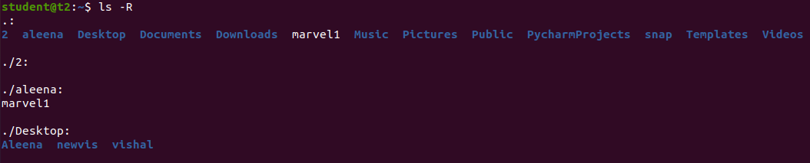

1. **ls –l :**

It will show the list in a long list format.

$ls –l

**Output Screenshot:**

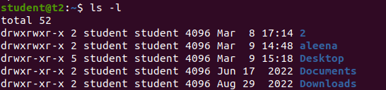

1. **ls –a :**

It will list all the hidden files.

$ls -a

**Output Screenshot:**



1. **ls –al :**

It will enlist the whole list of the current directory including the hidden files.

$ls -al

**Output Screenshot:**

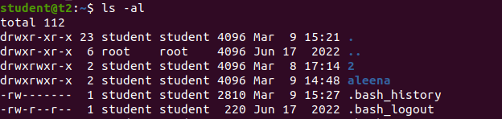

1. **ls –t :**

It list the file sorted in the order of last modified at top.

$ls -t

**Output Screenshot:**



1. **ls –r:**

It is used to print the list in reverse order.

$ls -r

**Output Screenshot:**



1. **mkdir :**

To create new working directory.

$mkdir directoryname

**Output Screenshot:**



1. **cd directoryname :**

Changes the current working directory.

$cd directoryname

**Output Screenshot:**



1. **cd .. :**

To move one directory up.

$cd ..

**Output Screenshot:**



1. **history :**

To view the commands and the history which have been executed on certain period of time.

$history

**Output Screenshot:**

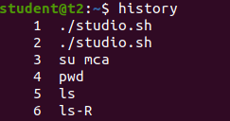

1. **man ls :**

We can learn and understand about different commands right from the shell.

$man ls

**Output Screenshot:**



1. **cat > filename :**

It is used to create a new file.

$cat > filename

**Output Screenshot:**

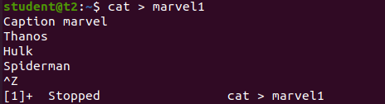

1. **cat filename :**

To display the content in the file.

$cat filename

**Output Screenshot:**

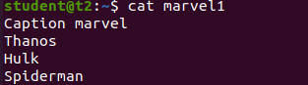

1. **cat >> filename :**

To append the contents into the file.

$cat >> filename

**Output Screenshot:**

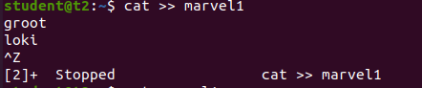

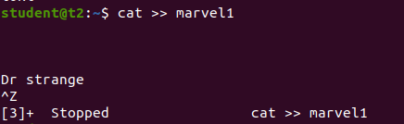

1. **cat –n filename :**

To display line numbers.

$cat –n filename

**Output Screenshot:**

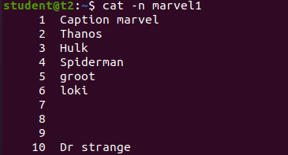

1. **cat –b filename :**

To remove the numbering of empty lines.

$cat –b filename

**Output Screenshot:**

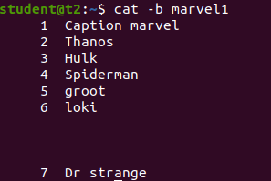

**Result**

The program was executed and the result was successfully obtained. Thus CO2 was obtained.

**Experiment No.:**

**Aim**

**CO**

**Procedure**

**Result**